**GitHub Link:** <https://github.com/seexiong/final-project>

**Homepage HTML Validation**

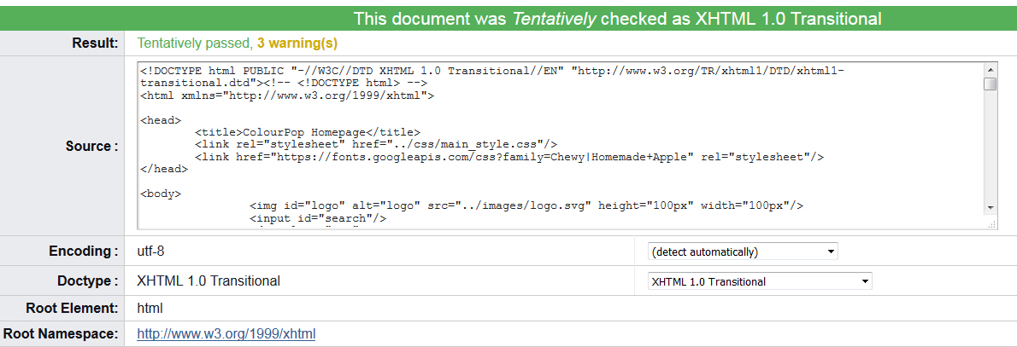

**Homepage CSS Validation**

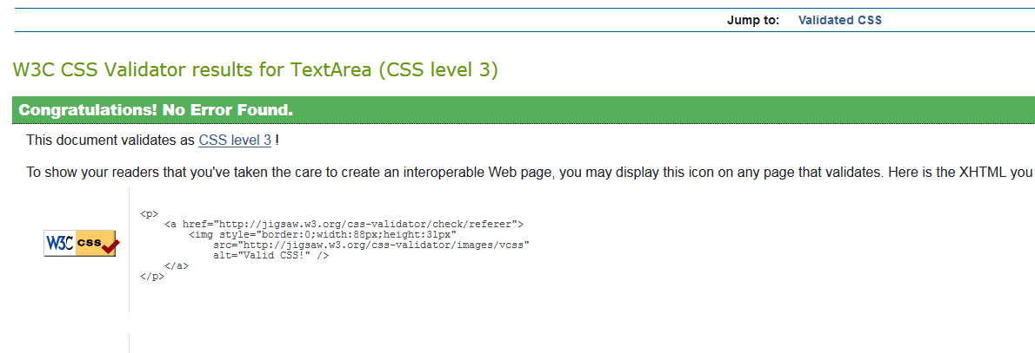

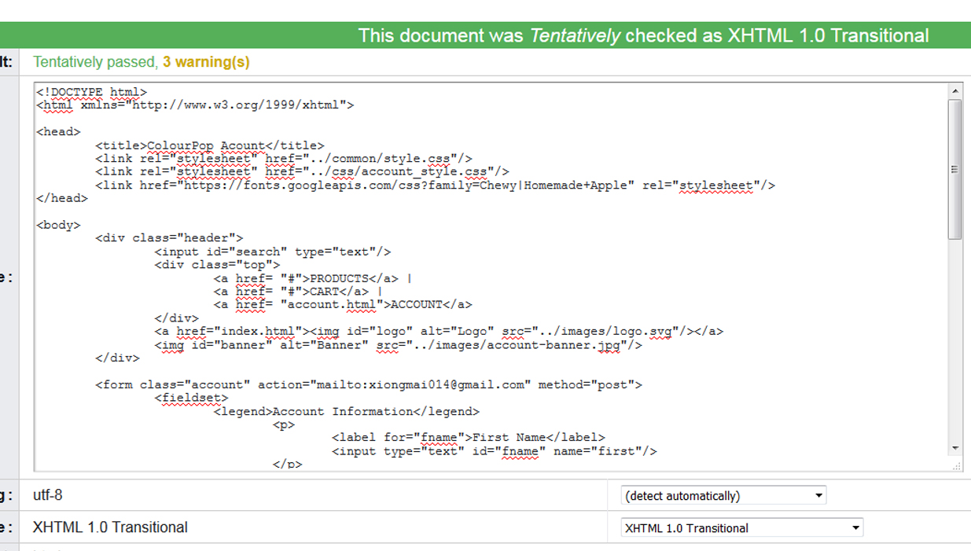**Account Page HTML Validation**

**Account Page CSS Validation**

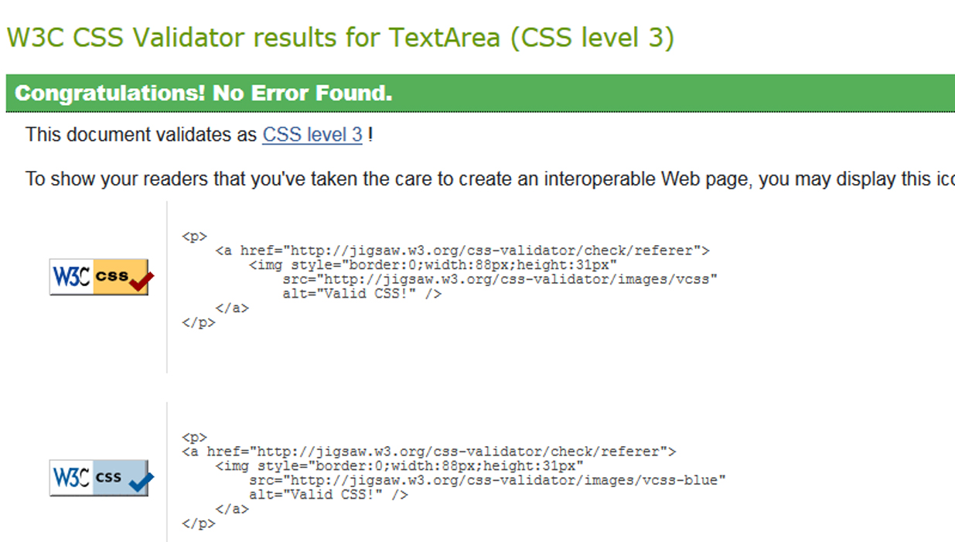

**Product Page HTML Validation**

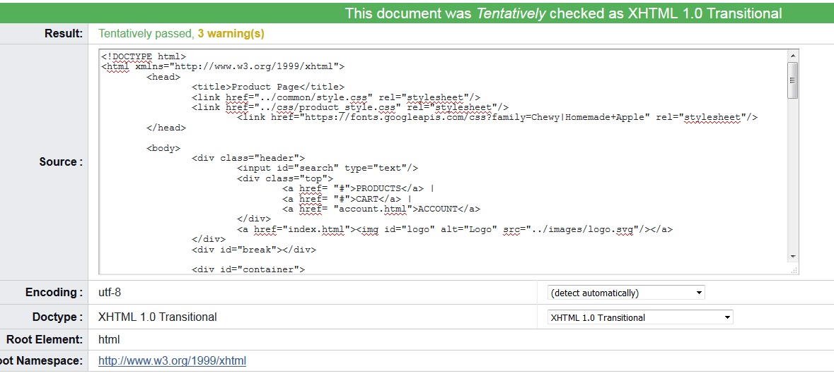

**Product Page CSS Validation**

